**Project Objectives**

**Proposed Solution Template**

|  |  |
| --- | --- |
| Date | 25 September 2022 |
| Team ID | PNT2022TMID45285 |
| Project Name | IoT Based gadget for child safety monitoring and notification |
| Maximum Marks | 4 Marks |

**Proposed Solution Template:**

PROPOSED SYSTEM:

In the existing system, manual intervention was required. But in the proposed system, we make every action automatically.

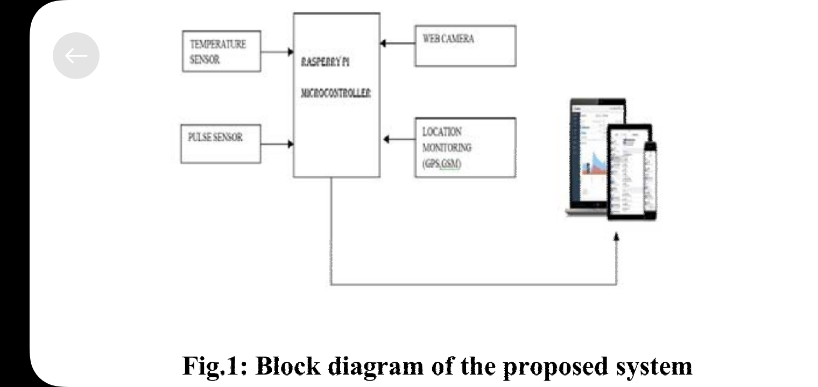

We can use both web application as well as mobile application or either one of it as the front end user interface, cloud, and database as the back end for storing and retrieving information, and a device for monitoring.

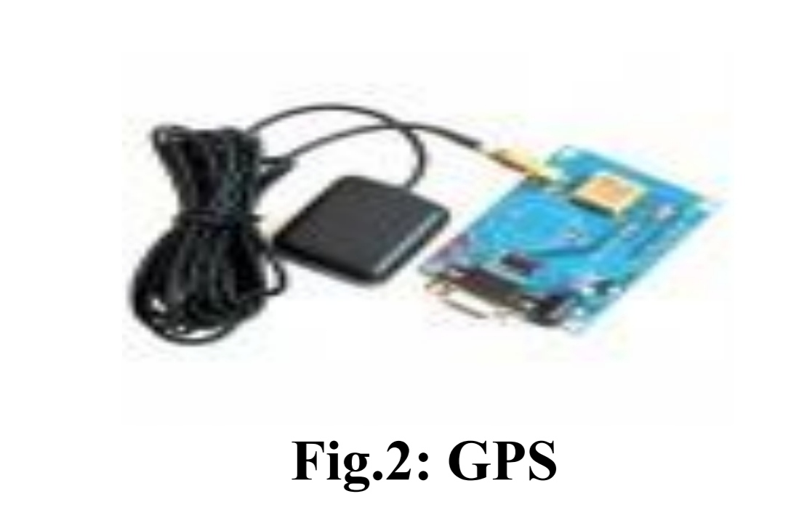

GPS is used to track the live location of the child who is wearing that device. With the help of GPS, we can easily perform Geo-fencing concept, in which we will be able to feed a particular boundary to that device.

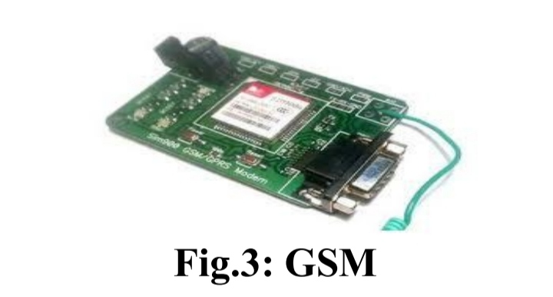

If the child goes beyond that particular boundary specified, the respective guardians will receive an alert call using GSM. In our system, we use several components like,

1.Temperature sensor

2.Pulse sensor

3.GPS

4.GSM

5.Web camera

6.Raspberry pi microprocessor

The Temperature sensor is used to sense the surrounding temperature of the device. If the temperature level exceeds the room temperature then the alert message will be sent using GSM to the specified users.

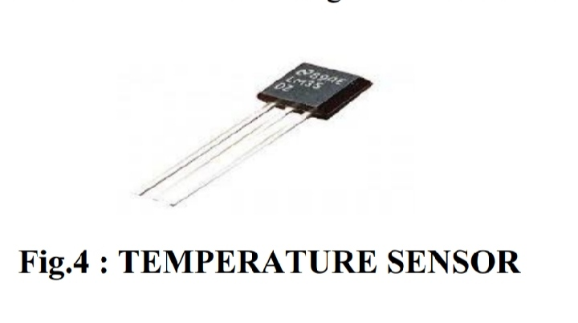

The Pulse sensor is used to detect any abnormal feelings experienced by the child like fear, anxiety, nervousness, drowsiness and several other illnesses which manipulates the normal heart rate.

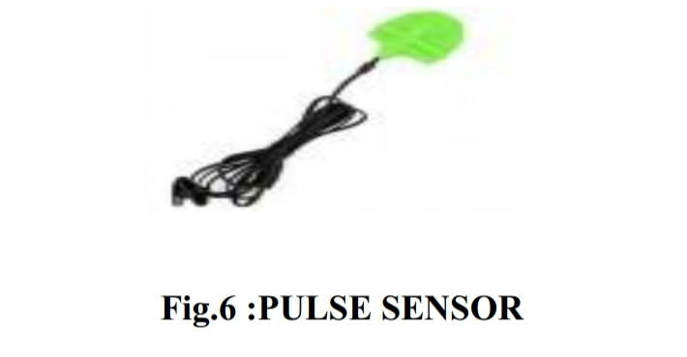

These values are used to alert the specified guardians through SMS using GSM. When the user receives these alert messages from that device, they can turn on the web camera placed in that device, with which they can visually monitor the status of that child through the live video stream.

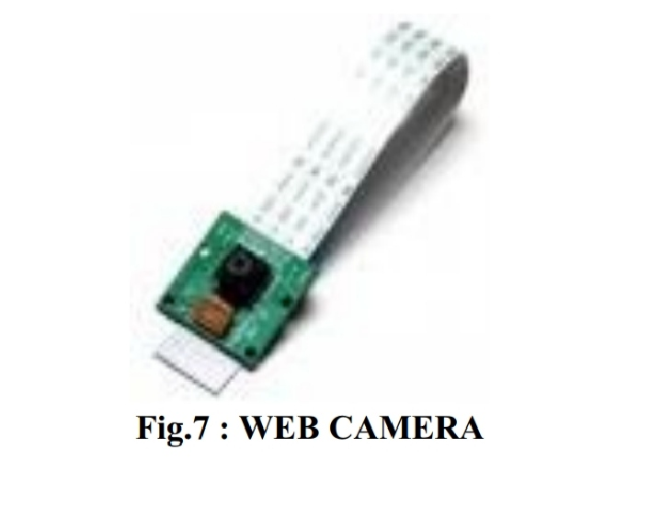

WORKING

Our proposed system consists of Raspberry Pi microprocessor in which all other sensors, GPS and GSM are integrated. The users are required to register using their credentials to use the application. The device will be given to the children for monitoring them regularly. We will feed the boundary value while writing code for the system and we control it using GPS for that device which is also known as Geo Fencing. These data are stored in the server.

RESULTS

One of the module in our project is temperature sensor which is used to detect the temperature of the child as well as the surrounding temperature. If there occurs any abnormal rise or fall in temperature in the body of the child or in the surrounding it will notify the user as per the coded time delay as shown in the picture. It will show the temperature and humidity values notifies the user based on the predefined value abnormal fall or rise scenarios.